Ai Assistant
Lab exam
Name: srija
2303A52412
Batch 44
SET B
Q3. Zero-Shot List Analysis
Scenario:
You want AI to generate logic without giving examples.
Task:
Write a Python function that:
• Accepts a list of integers
• Returns the sum of all numbers greater than 10
Test the function with sample input.
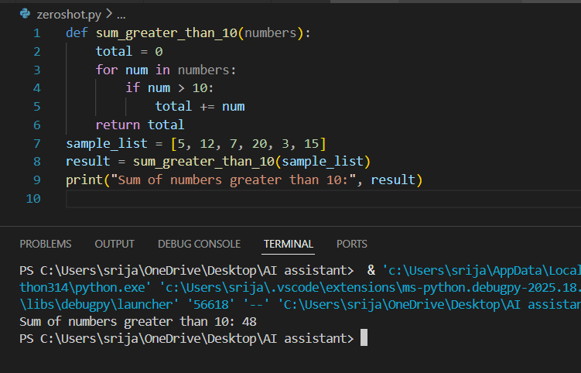
Observation:
- The function correctly accepts a list of integers as input.
- It checks each number and selects only those greater than 10.
- The program adds the selected numbers and returns the final sum.
- If no numbers are greater than 10, the function returns 0, ensuring stability.
- The logic is simple, efficient, and easy to understand.

Q4. Exception Handling
Scenario:
The following program may cause an error:
num = int(input("Enter a number: "))
result = 100 / num
print(result)
Task:
Use AI assistance to:
• Prevent division by zero
• Handle invalid input
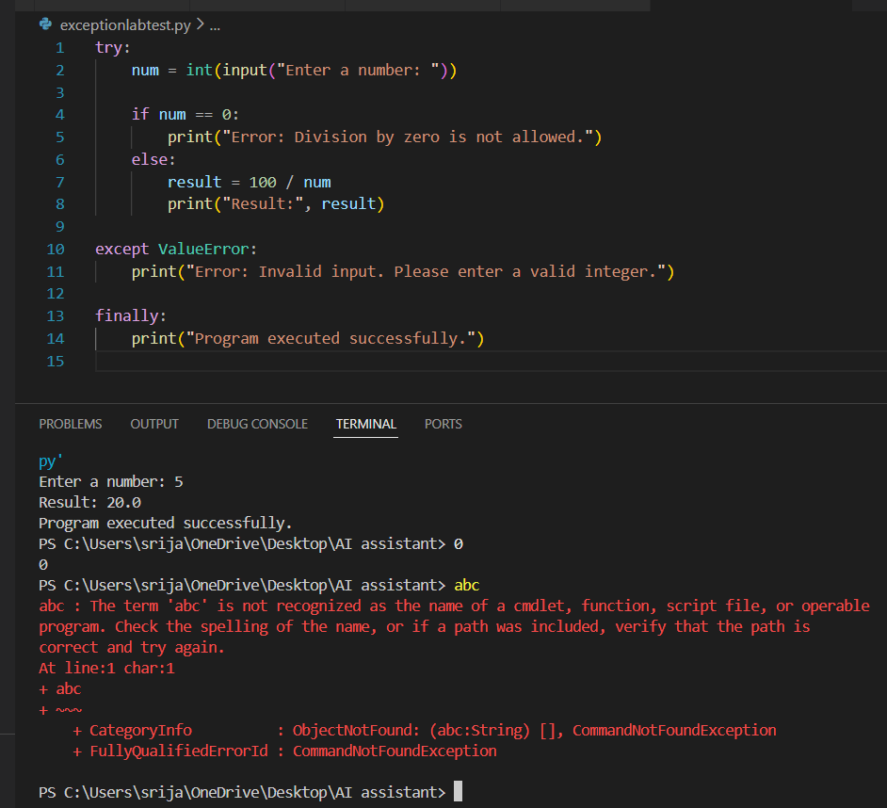
Observation:
- The program successfully handles errors using exception handling.
- It prevents division by zero by checking whether the entered number is 0.
- It catches invalid inputs (such as letters or special characters) using ValueError.
- Meaningful error messages guide the user to provide correct input.
- The finally block ensures that a completion message is displayed regardless of whether an error occurs.

